Keys Le

5/1/20

Lab 2 Descriptive Statistics

There were a total of 45 participants, reported to be trauma survivors with PTSD symptoms (ptss). The participants were selected at random to four different groups. The four groups were Stress Inoculation Therapy (SIT), Prolonged Exposure (PE), Supportive Counseling (SC), and a Waiting List (WL). SIT had 14 participants who were taught a variety of coping skills. PE had 10 participants repeat trauma in their minds for a total of seven sessions. SC had 11 participants in the standard therapy control group. WL had 10 participants in the control group. The mean of the ptss group had a mean of 15.62 (*SD* = 7.96). There was a minimum value of 2 and maximum value of 34 for reported ptss. The SIT treatment group had the lowest mean (*M* = 11.07; *SD* = 3.95), followed by the PE group (*M* = 15.40; *SD* = 11.12), the SC group (*M* = 18.09; *SD* = 7.13), and the WL group (*M* = 19.5, *SD* = 7.11). Refer to table 1 for descriptive statistics on ptss per treatment group including: mean, standard deviation, min, and max. A boxplot of the data is presented in figure 1.

A one-way analysis of variance was conducted to evaluate the effect of various therapies on trauma survivors who experienced ptss. The independent variable was therapy with four various styles of therapy SIT(n = 14), PE(n = 10), SC(n = 11), and WL(n = 10) while the dependent variable was post traumatic stress symptoms. The ANOVA was significant, *F*(3, 41) = 3.05, *p* = 0.04. Refer to table 2 ANOVA table. Among the groups a significant difference was seen in ptss between WL and SIT group (mean difference = 8.43, *p* < 0.04) such that the SIT

(*M* = 11.07) and WL (*M* = 19.5).

|  |  |  |  |  |  |
| --- | --- | --- | --- | --- | --- |
| Table 1 . | | | | | |
| *Descriptive Statistics on Post-Traumatic Stress Symptoms per Treatment Group* | | | | | |
| Treatment | *N* | *M* | *SD* | Min | Max |
| SIT | 14 | 11.07 | 3.95 | 3.00 | 18.00 |
| PE | 10 | 15.4 | 11.12 | 2.00 | 34.00 |
| SC | 11 | 18.09 | 7.13 | 5.00 | 27.00 |
| WL | 10 | 19.5 | 7.11 | 12.00 | 30.00 |
| Total | 45 | 16.75 | 7.12 | 4.00 | 28.5 |

*Note*: *N* = sample size; *M* = mean; *SD* = standard deviation; Min = minimum; Max = maximum

These data indicate the SIT group had the lowest mean and standard deviation with the highest amount of participants. The more participants in a treatment group would have a larger distribution than the other groups. The descriptive data shows that the SIT group had less post traumatic stress symptoms compared to PE, SC, WL.

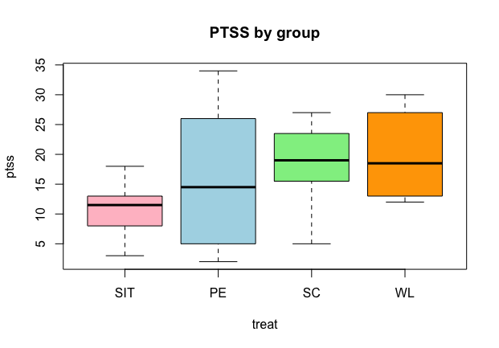

*Figure 1. Boxplot PTSS by Group*

Viewing the boxplot we can see the SC group has the greater median of all the treatment groups. SIT group mean post-traumatic stress symptoms varies much less than that of the other groups. SC group is more consistent mean post-traumatic stress symptoms should make predictions on treatment more dependable than that of the other groups. The mean of the SIT and SC group is less than the median value, indicating they are skewed. The PE group has the largest range of all the treatment groups. The PE group shows a maximum value of 34 for post- traumatic stress symptoms as compared to the other treatments groups. The evidence shows that repeated exposures for a total of 7 sessions had a higher max of post-traumatic stress symptoms than the other groups.

Table 2.

*ANOVA table*

|  |  |  |  |  |  |
| --- | --- | --- | --- | --- | --- |
|  | Df | Sum Sq | Mean Sq | F value | Pr(>F) |
| treat | 3 | 507.8 | 169.28 | 3.046 | 0.0394 |
| Residuals | 41 | 2278.7 | 55.58 |  |  |

pts.df = read.csv("PTSS_Therapy.csv", header=T)  
# ## HELP NOTE: type in ?relevel in the console to learn more  
pts.df$treat= relevel(pts.df$treat,'SIT')  
names(pts.df)

[1] "ptss" "treat"

summary(pts.df)

ptss treat   
 Min. : 2.00 SIT:14   
 1st Qu.:10.00 PE :10   
 Median :14.00 SC :11   
 Mean :15.62 WL :10   
 3rd Qu.:21.00   
 Max. :34.00

boxplot(ptss~treat,data=pts.df,col=(1:4)+1)

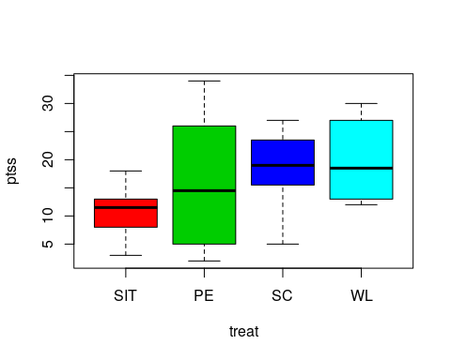

aov1 = aov(ptss ~ treat, data = pts.df)  
summary(aov1)

Df Sum Sq Mean Sq F value Pr(>F)   
treat 3 507.8 169.28 3.046 0.0394 *  
Residuals 41 2278.7 55.58   
---  
Signif. codes: 0 '***' 0.001 '**' 0.01 '*' 0.05 '.' 0.1 ' ' 1

gmus = with(pts.df, aggregate(ptss ~ treat, FUN=mean))  
gmus

treat ptss  
1 SIT 11.07143  
2 PE 15.40000  
3 SC 18.09091  
4 WL 19.50000

tk1 = TukeyHSD(aov1)  
tk1

Tukey multiple comparisons of means  
 95% family-wise confidence level  
  
Fit: aov(formula = ptss ~ treat, data = pts.df)  
  
$treat  
 diff lwr upr p adj  
PE-SIT 4.328571 -3.9364832 12.59363 0.5051618  
SC-SIT 7.019481 -1.0234398 15.06240 0.1062481  
WL-SIT 8.428571 0.1635168 16.69363 0.0441454  
SC-PE 2.690909 -6.0311179 11.41294 0.8417772  
WL-PE 4.100000 -4.8272793 13.02728 0.6118884  
WL-SC 1.409091 -7.3129361 10.13112 0.9725237